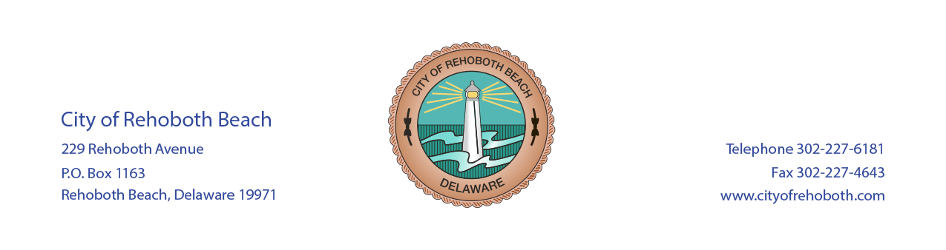

CITY OF REHOBOTH BEACH MUNICIPAL ELECTION TO BE HELD ON AUGUST 12, 2017
Annual Municipal Elections for the City of Rehoboth Beach are held on the second Saturday in August from 10:00 a.m. until 6:00 p.m. Due to ongoing construction of the City Hall Municipal complex, the annual election will be held at the Rehoboth Beach Fire Department located at 219 Rehoboth Avenue.
At such annual election, every natural person, male or female, who shall have attained the age of Eighteen (18) years and who shall be a resident, freeholder or leaseholder, and who is registered on the Books of Registered Voters of The City of Rehoboth Beach shall have one (1) vote. If you would like to review the City’s Charter, you may do so by going to the City’s website, www.cityofrehoboth.com.
If you meet any of the above qualifications, and are eligible to vote in annual elections, you must appear in person at City Hall to complete a voter registration card. Please bring your driver’s license or a photo ID with you.
If you miss two (2) consecutive annual elections, your name will be removed from the voter registration list. You will be notified by registered/certified mail and you must appear in person at City Hall to re-register to vote.
The deadline for voter registration is the close of business on Thursday, July 13, 2017.
You can vote by absentee ballot. An affidavit must be completed and filed no later than noon on August 11, 2017. You may obtain an affidavit by going to the City’s website, www.cityofrehoboth.com, or by calling City Hall at 302-227-6181, ext. 108 to request an affidavit be mailed to you.
PLEASE RETURN AFFIDAVIT TO: City of Rehoboth Beach, 229 Rehoboth Avenue, Rehoboth Beach, DE 19971
You MUST COMPLETE the left column of the Affidavit. Please read the other two (2) sections, and only complete one (1) section. (Complete the section which pertains to WHY YOU WILL BE ABSENT FROM THE POLLING PLACE the day of the Election)
Absentee ballots will be available forty-five (45) days prior to Election Day on June 28, 2017. Ballots will be sent to everyone who has an affidavit on file. The deadline for the City to mail Ballots is the last Tuesday prior to the Election on August 8, 2017. Ballots MUST be received by mail or in person before the Polls close on the day of the Election.
For questions or other information regarding the annual election, please contact Ms. Donna Moore at 302-227-6181, ext. 108. Thank you for your interest in The City of Rehoboth Beach annual elections.
Posted on Bulletin Board – 4/10/17
Sent to Communications to be posted on website – 4/10/17
Department of Elections – 4/10/17
Commissioner of Elections – 4/10/17

